Adapter Design  
  
  
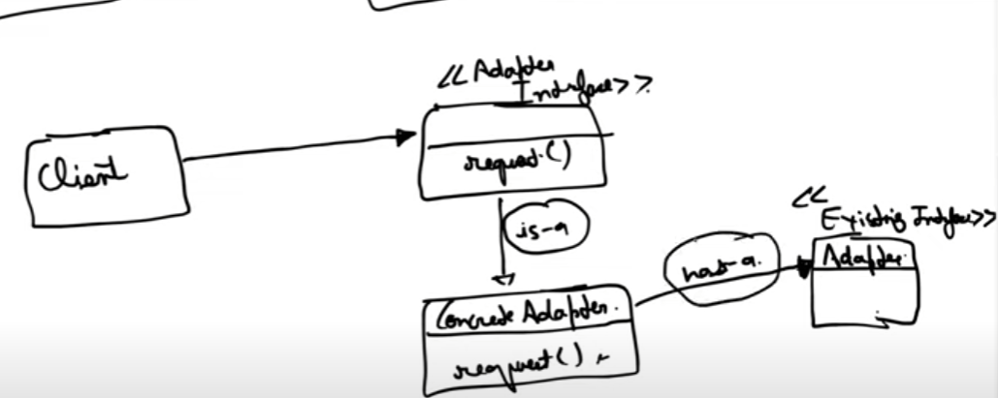  
  
  
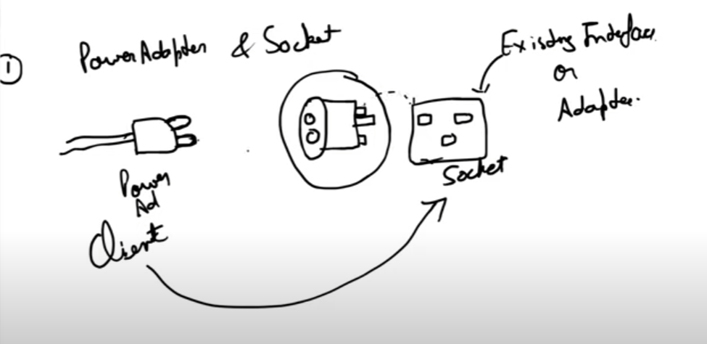  
  
suppose client wants to talk to socket which uses an existing interface but that’s not possible. In such a scenario we use and adapter.  
  
  
